Day – 1 Assignment
- Draw a labeled diagram of a typical home Wi-Fi setup showing a modem, router, switch, access point, and at least two devices (like a laptop and smartphone) connected to the network.
Ans :
Internet
│
│
+---------------+
| Modem |
+---------------+
│
│
+---------------+
| Router |
| (DHCP / NAT) |
+---------------+
│ │
Ethernet │ │ Wi-Fi
│ │
+----------------+ │
| Switch | │
+----------------+ │
│ │ │
│ │ │
+---------+ +-----------+ +----------------+
| Desktop | | Access |~~~~~~| Smartphone |
| PC | | Point | +----------------+
+---------+ +-----------+
│
Wi-Fi │
│
+----------------+
| Laptop |
+----------------+

2. List the main function of each networking hardware device: modem, router, switch, access point, and network cable. For each, give a real-life example of where you might see or use it (for example, 'router: at home to share internet').
Ans:
Networking Device | Main Function | Real-Life Example
Modem | Connects your home or office network to the Internet through the Internet Service Provider (ISP). It converts the ISP's signal into a form your network can use. | Home or office – Connected to the ISP's fiber, cable, or DSL line to provide Internet access.
Router | Connects multiple devices to the Internet and routes data between your local network and the Internet. It also provides features like DHCP, NAT, and firewall protection. | At home – Shares one Internet connection with laptops, smartphones, smart TVs, and other devices.
Switch | Connects multiple wired devices within the same Local Area Network (LAN) and forwards data only to the intended device. | Office or computer lab – Connects desktop computers, printers, servers, and IP phones using Ethernet cables.
Access Point (AP) | Provides or extends Wi-Fi coverage so wireless devices can connect to the network. | School, college, office, or shopping mall – Provides Wi-Fi access in different rooms or floors.
Network Cable (Ethernet Cable) | Physically connects network devices and carries data between them at high speed. Common types include Cat5e, Cat6, and Cat6a. | Home or office – Connects a PC to a switch or router, or connects a switch to an access point.

3. Take photos or find images online (with source links) of at least three types of network cables (such as Ethernet, coaxial, fiber optic) and write one line describing where each is commonly used.
Ans:
1. Ethernet Cable (Twisted Pair – Cat5e/Cat6)
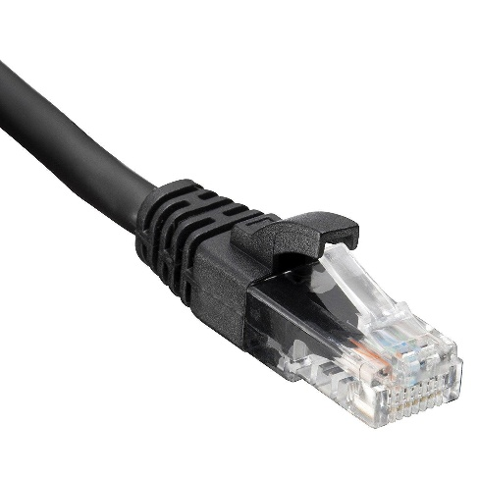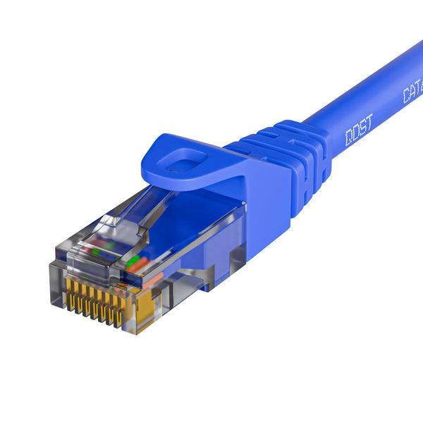

- Common use: Used to connect computers, routers, switches, printers, and access points in home and office networks

2. Coaxial Cable
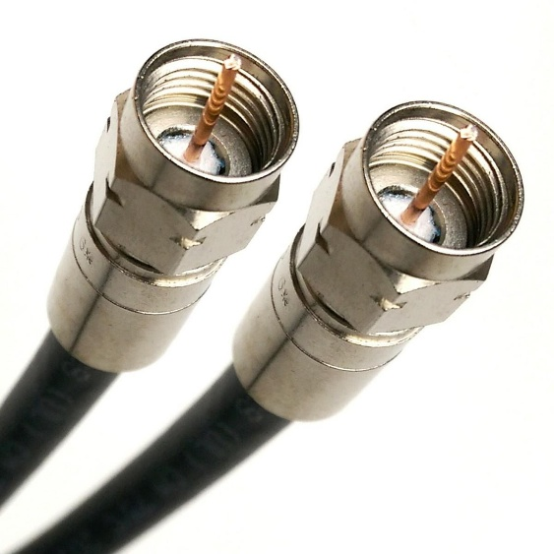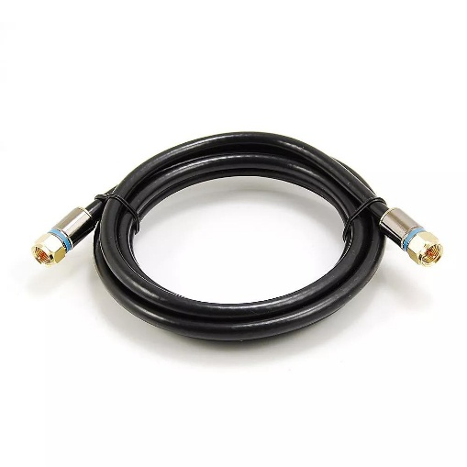

- Common use: Used for cable TV, cable Internet connections, and connecting a cable modem to the ISP line

3. Fiber Optic Cable
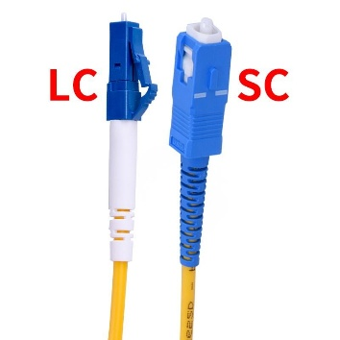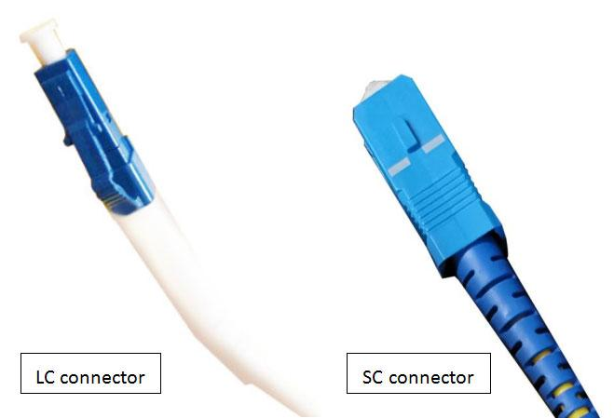

- Common use: Used by Internet Service Providers (ISPs), data centers, and enterprises for high-speed, long-distance network connections.

4. Create a comparison table listing at least four differences between a router and a switch, including their main use, typical location, and how they handle data.
Ans :
Feature | Router | Switch
Main Use | Connects different networks (such as a home network to the Internet) and shares the Internet connection. | Connects multiple devices within the same Local Area Network (LAN).
Typical Location | Found in homes, offices, schools, and businesses at the network gateway. | Found in offices, computer labs, server rooms, and large home networks.
How It Handles Data | Routes data packets between different networks using IP addresses. | Forwards data frames within the same network using MAC addresses.
Internet Connection | Can connect directly to a modem and provide Internet access to all devices. | Cannot connect directly to the Internet; it relies on a router.
Number of Ports | Usually has 4–8 LAN ports and 1 WAN port. | Available with many ports, such as 8, 16, 24, or 48 Ethernet ports.
OSI Layer | Operates mainly at Layer 3 (Network Layer). | Operates mainly at Layer 2 (Data Link Layer).
Example | A Wi-Fi router used at home to connect laptops, smartphones, and smart TVs to the Internet. | A 24-port switch used in an office to connect desktop computers, printers, and servers.

